When in Bear Country:
“The Actions of Dumb People are the Cause of Smart Bears!”

The difference between the ‘intelligence’ of the bears at Philmont Scout Ranch
and the National Parks is phenomenal.
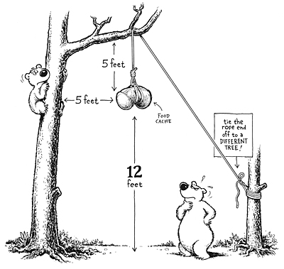
This is entirely due to the training of the Crews by the Philmont Rangers, and the Crews actually following through with the training.
10 feet
The way we do ‘Bear Bagging’ at Philmont (using bear cables strung between two trees), is similar to this illustration. However, you could never get away with using this method at a National Park such as Yosemite, because the bears would get your food and it would be illegal. You must use ‘bear canisters’ in Yosemite.

At Philmont, the Bear-Bag rope is doubled and a loop is tied in the middle, the food and ‘smellables’ bags are attached to the rope using Lark’s Head knots positioned as close as possible to this loop. The rope’s ends are tied to two different trees.
A carabineer is attached to the loop and another bear-rope is run through the carabineer to use as a second Bear Bag rope for your “Oops-Bag”. The oops-bag is for any gear that needs to go up later, or before bed-time, without bringing the whole unit down.

In normal ‘non-tourist’ far off-track wilderness locations using the above illustration may work just fine, and it usually does …it all depends on the local bears.

But when you come down to the root cause of ‘Smart Bears’, that have learned how to get to your food, it is not a ‘bear-problem’ it is a ‘people-problem’, or closer yet... ‘Problem-people’.

(illustration source) http://www.trailspace.com/articles/2009/10/07/book-review-bear-essentials.html#comment61972
Book Review: “Bear Essentials: Hiking and Camping in Bear Country”

Hiking and Camping Safely in Bear Country
http://www.trailspace.com/articles/hiking-and-camping-in-bear-country.html

“The animal shall not be measured by man. In a world older and more complete than ours they move finished and complete, gifted with extensions of the senses we have lost or never attained, living by voices we shall never hear. They are not our brethren, they are not underlings; they are other nations caught with ourselves in the net of life and time.” -- Henry Beston, naturalist and author
This document is from:
https://www.pineapplefish56.net/Scouting-Fun.html
v1.2

